Hock: Here’s something for the IC Assault Rifle
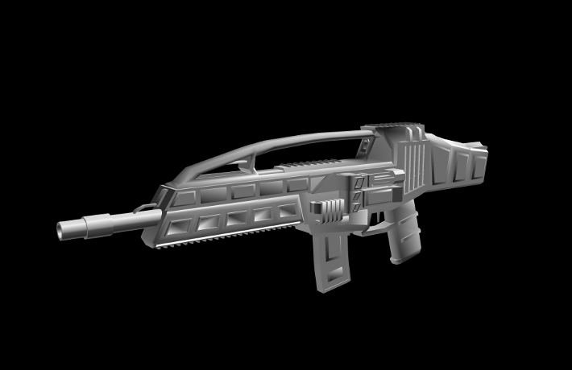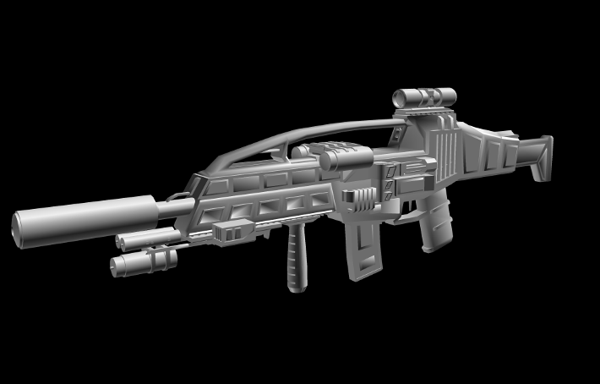
Difference between Vanilla and fully upgraded (You can always enlarge the pictures if you want).
Add-ons remain the same except some little modifications on the laser modules and a personalized stock.
Hock: I got something for you, Finn.
So, I’ve been tinkering with the Aleph entries for a while, and I got a model + bounding boxes (let’s just refrain from saying “cvh”) and I was wondering if you could write code in order that they are placed in randomness (perhaps placed after that line-creation-generation of flat terrain you said, in the end/start of those said lines, plus more random placement) and they must be placed in strictly flat terrain, just to save a lot of headaches. So, I heard that P3D had this “thread processing” which theoretically could make it even more seamless, so I wrapped up my stuff and put it in this folder:
Hock's stuff\Models\EGG format\Testing\Test Alephs1
It contains the files “Aleph_Hull.egg” and “Aleph_Body.egg” (names are self-explanatory). Aleph_Body is the structure itself, with the part that connects it to the ground at 0,0,0 (X,Y,Z); to “plant” it, just make the engine throw a raycast and were the ray collides with the ground, make it place the origin of the Aleph_Body (that 0,0,0) exactly where the raycast collided with the terrain (flattened terrain, of course). Exactly the same procedure to place Aleph_Hull, which contains the collision meshes. One thing: All objects on Aleph_Hull are convex, so no worries. The object the player must collide to warp into another sector is named “Hull38”. I’m no coder, so feel free to arrange something that I may have messed up – and don’t hesitate on asking me to “refurbish” the models if something is not working right.
(I had initially wanted the Aleph model to have animation, but for now, that’s just too much work, both for you and for me – and Milkshape doesn’t want to collaborate either. I’ll keep you updated.)

Sambasti: And, here I go again. What are the compatible extensions for models in Panda? And with controls I meant what section of the code determines that the camera will be moved with wasd. I want to know so I can analyze it and possibly try to import a movable tank.
Hock: Panda will only read the .egg, .x, and .bam format, though the .egg format is what you'd be aiming for. Go to the console, “cd” to where your model is (you must have exported it to .x format) and then type "x2egg input.x output.egg". You can check animations on a model by typing "pview model.x" or "pview model.egg". To export X files from Wings you must have first to uncheck "Export UV coordinates" on the export dialog for DirectX, or else the file won't work. I got a collection of articles specific to 3D models on Panda’s manual in my folder; you might want to check that out.
Hock: I changed the ugly, old and claustrophobic ASCII notepad format to this clean and functional version of the lounge file. I’m a graphics designer, what’d you expect? Plus, we got spellchecking now! And images!
Since everyone can read .doc (Linux and MacOS too) I guess we’re fine. No reason why we should develop in something that looks and feels like 1980. I’ll keep the old version up for a few days.
Hock: I’d like to know what everyone thinks about Weapon accessories. If you saw my recent IC SMG; you may have noticed it does have a lot of Picatinni rails (like the H&K UMP, from which I inspired from). Well, I was staring at those rails and I thought, why not add some more dynamism to the weapons and the evolution of the player. I have designed here some accessories; I’d like to know what you think (theoretically you can use them on any gun).
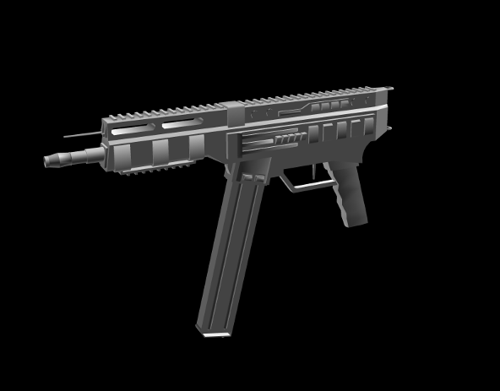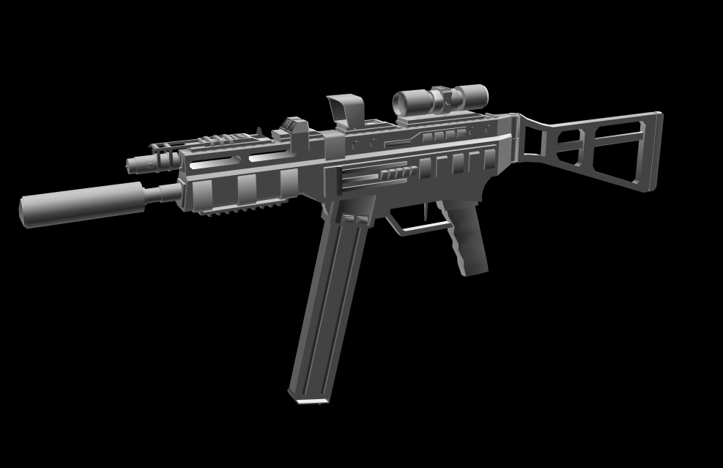
Difference between Vanilla and fully upgraded.
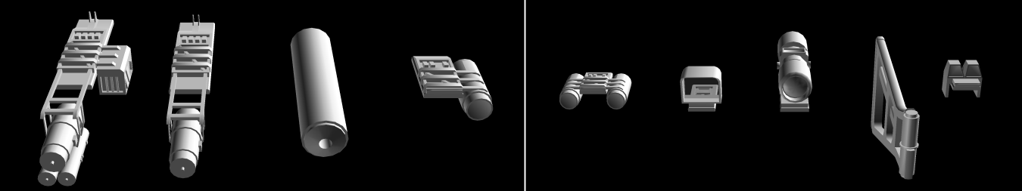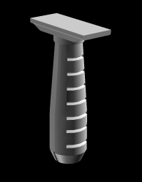
From left to right: Adaptable Laser (modifies laser point according to bullet drop), Laser, Silencer, Single Tac-Light, Double Tac-Light, Reflex Sight, Small Scope, Removable Stock, Iron sights (Default) and Forward Grip (+accuracy)

Finn: this slipped passed me, sorry. The mines were transparent, but there were some serious depth related issues unfortunately, I think it would be best to just avoid transparency altogether.
Before you do too much work on joints, make sure they can import correctly, I’d be happy to test for you when you put a test up.
Collision meshes, I’m good for now, still doing the "environment"
I’m working on a map editor right now, as that lets me get everything working together without it being such a huge project, plus you guys will be able to make some maps/test the codebase.
Sambasti: Where can I find the controls? And how does the importing of modules work? <--Learned a bit of Basic at an earlier time, and is now confused.
Finn: Controls? You mean the keyboard commands? wasd<space> and the F# keys (don’t remember which, just click them all and see what happens, 1 locks the game up for a few seconds, but you shouldn’t have to worry about it. also, mouse for direction. (Left click picks up the multi-colored box, but that may be disabled)
Importing is just: import <blah>
Or: from <blah> import <blah>, <blah>...
Sambasti: Actually, I meant where I can find the controls in the code, how does python recognize models.
Finn: Ah, sorry, you mean the command and functions to make panda3d do stuff?
http://panda3d.org/apiref.php?page=classes for a list of them, click manual if you want it explain in an easier to read way.
As for models,
blah = loader.loadModel("filepath/filename.fileExtension")
blah.reparentTo(render)
Will make the model appear in position 0, 0, 0
blah.setPos(num1,num2,num3)
Will move it to a new position (you might need this if you’re using one of the apps with terrain, since you want be able to see 0, 0, 0
Make sure you have import direct.directbase.DirectStart at the top
If you want other commands see the link above (hint, "blah" would be a NodePath).

Sambasti: Finn, could you explain a little bit about how you structured the main.py (Which file is controls, and what makes what) Thanks.
Don’t make it long, I just want to know what’s where so I can mess with it.
I managed to fix the heightfield2.
Uncommented : self.mHeightFieldNode.setPos( MAPSIZE/2, MAPSIZE/2, 0 )
Finn: As previously stated, I didn’t make all this code, it’s mostly an example given on the panda forums, I’m just using it as a base to test with until I have enough of my own code. That said, I think I’m starting to get how it works. The original programmer seems to have made a neat main.py... then they fucked it up by putting a load of code that should have had its own file in there. The the_days_after class is the one that starts the program note that it inherits from DirectObject. The step method inside it is what runs every frame.
Nice one fixing the heightfield2 file, I’ll try it out next time I’m on my pc.

The the_days_after class is the one that starts the program note that it inherits from DirectObject
The step method inside it is what runs every frame.
Nice one fixing the heightfield2 file, I’ll try it out next time I’m on my pc

Fuzz: We should get some flowcharts of what we've got so far.
Hock: Hey, could anyone replace the foliage in the procedural forest, by the models I have converted to .egg in Hocks stuff\Models\EGG format\Testing? I want to check if the x2egg converter is correctly reading everything and displays correctly the materials/transparency. Plus, how cool is a forest made of land mines?
Finn: Sorry for dealing with this so slowly hock, didn’t want to touch Test until I’d worked out what I was doing in the Quantus folder. I’ve imported all the changes from Quantus to test so you guys can see, notice the sunsets :), tried it and mines worked, I’ll keep the mine version up for a while, but it eats the fps too much. Oh and GIANT PINK MINES!!!!!

Hock: I only got one more question about that Finn; did the pink ones show any transparency, and was there any depth-related alpha issues or did it go seamless? The mine2.egg file had the pink/transparent material. On another note, I finally ended the clean-up on IC's (sexy) weapons (and I "upgraded" dare's ICAssRifle) and next thing I’m going to do it perhaps animate the guns (tripods, Gatling’s, recoils, etc.).
MS3D looks like a fine format to do this, only thing it does not support is blend/Morph targets, but I am not going to need that on guns (and since I can do the same with joints, I probably am not going to use them ever).
I have more questions. How do you think you are going to sync 2 or more different objects (say, a magazine, a gun and the player's hand?).
More info: Collision meshes can be made easily in Wings3D, they don't even need to be triangulated, so that's the easy (boring) part I'll leave to the end. Unless, of course, you require some for testing, in that case I'll be glad to push those forward.

